**How to install git on Windows**

**Objective:**

At the end of this session, Students should be able to

1. Understand the usage of git
2. Create github account and install git locally on Windows
3. Create repository and clone them
4. Familarize with commands like: clone, add, commit, push, pull

* **Usage of git?**

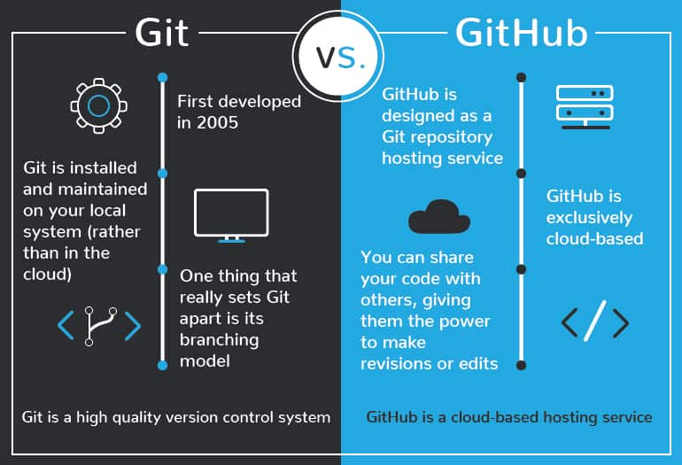

**Step 1: Create a github account**

1. Access the link <https://github.com/>
2. Sign up using your gmail account



1. Enter your mail and click on continue and create a password and click on continue and then give a user name and click on continue, then give yes or no, if you want to receive any product updates and click on continue

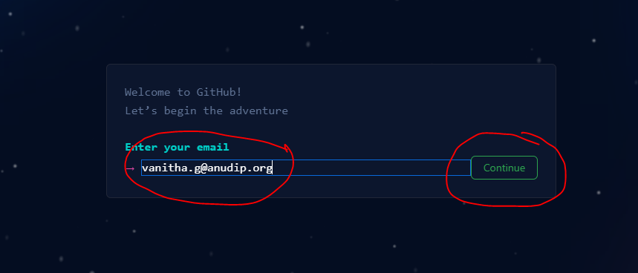

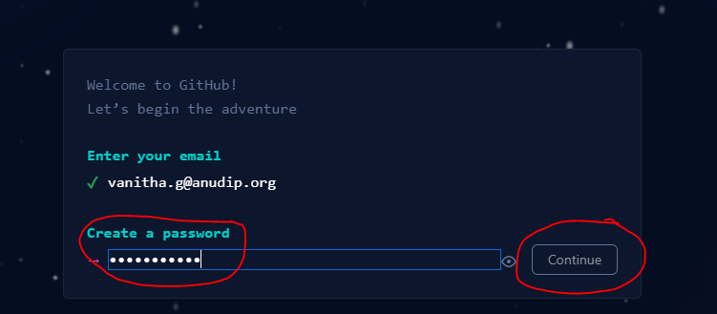

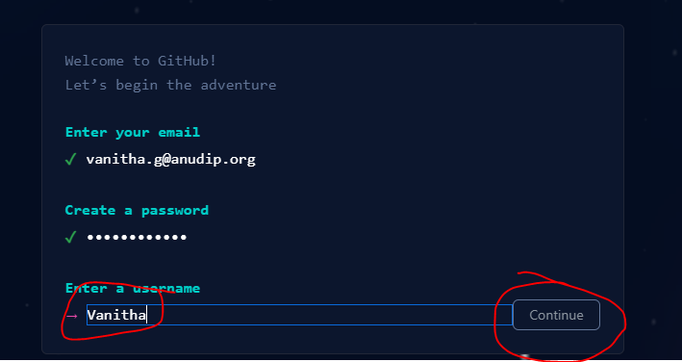

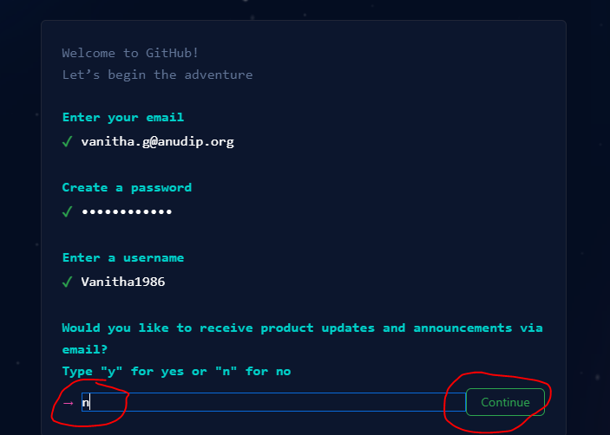

1. Solve the Puzzle to authenticate yourself, click on Start puzzle, once verification is done, click on create account

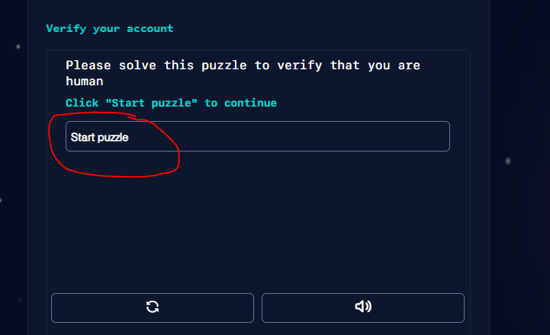

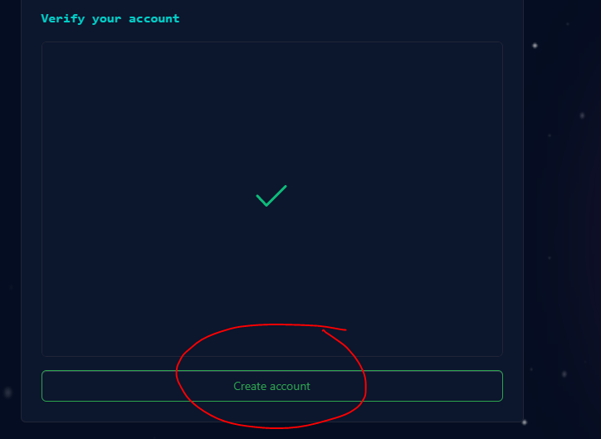

1. Enter the code you have received in your mailing account

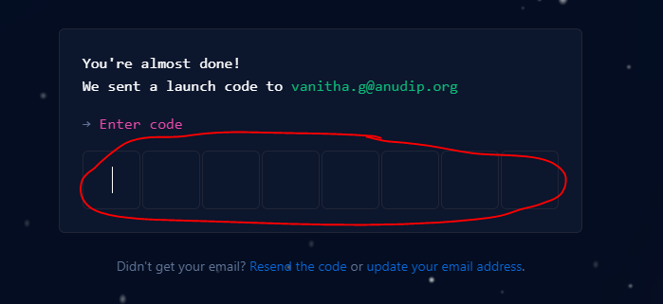

1. Select a student option for yourself, click on continue and select what for it you are using





1. Continue for free



1. Account is created, your dashboard should look like this

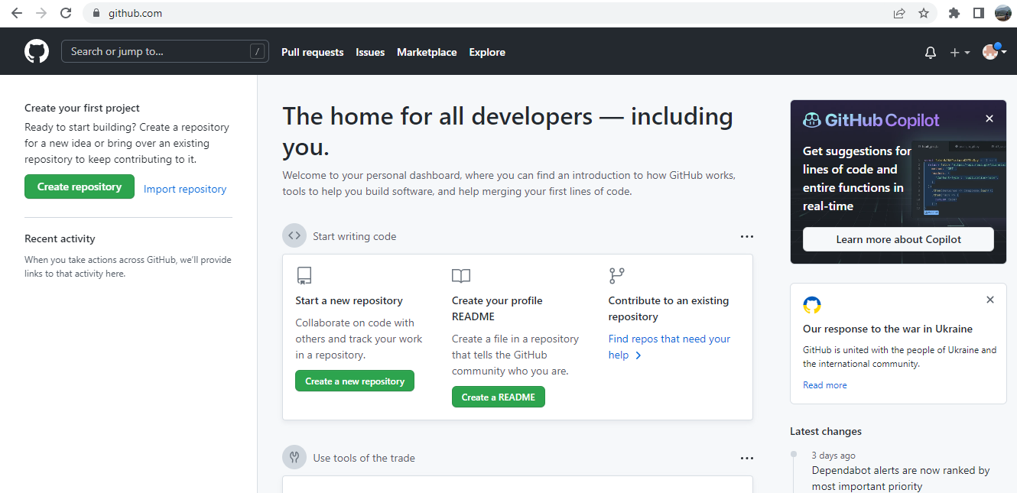

**Step 2: Creating a repository in Github**

1. Click on the + icon and select New repository, give a repository name, let it be public and select the option of add a Readme file and click on create repository option.

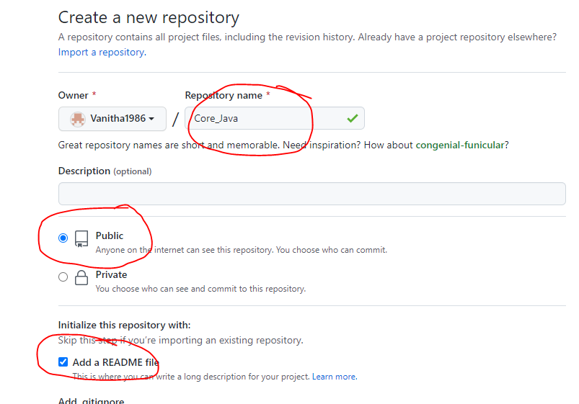

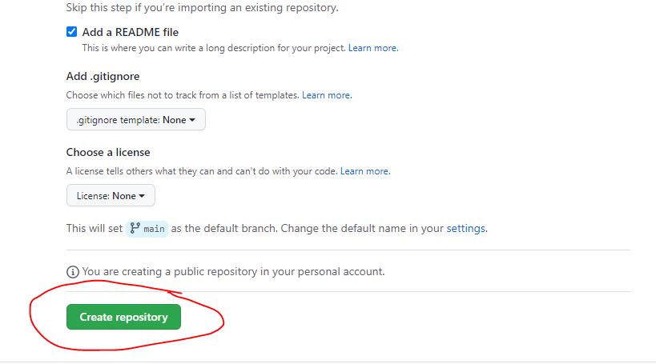

1. You should be able to see the dashboard as below

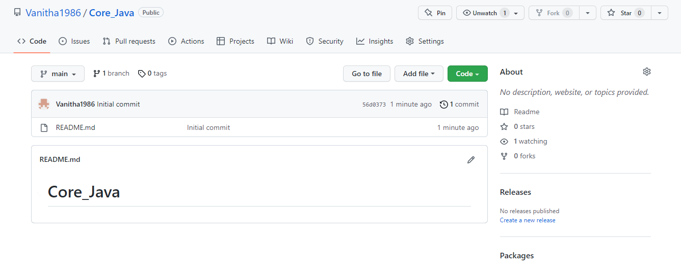

1. Click on the pencil icon and just add few lines of description for the repository, scroll down and click on commit changes

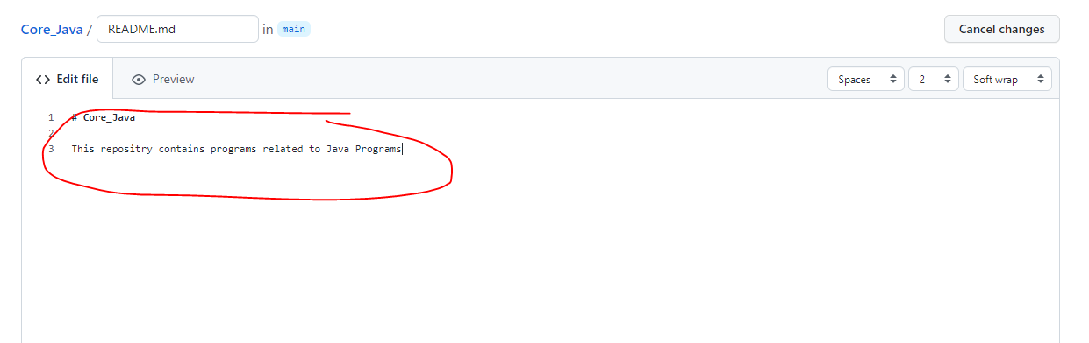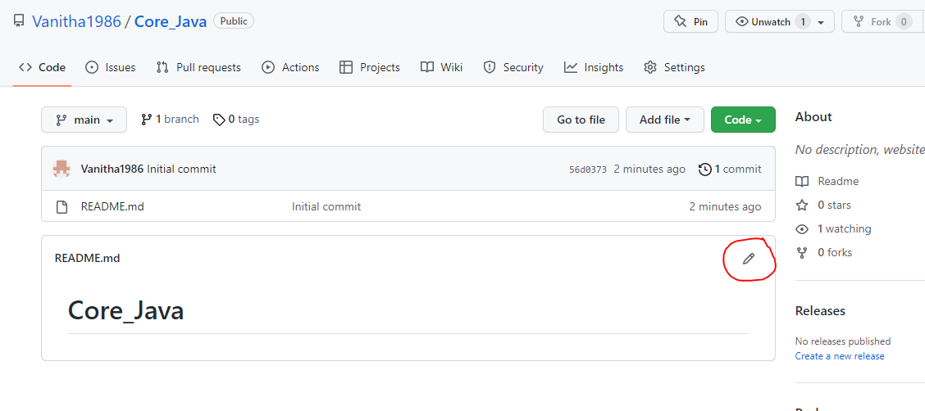

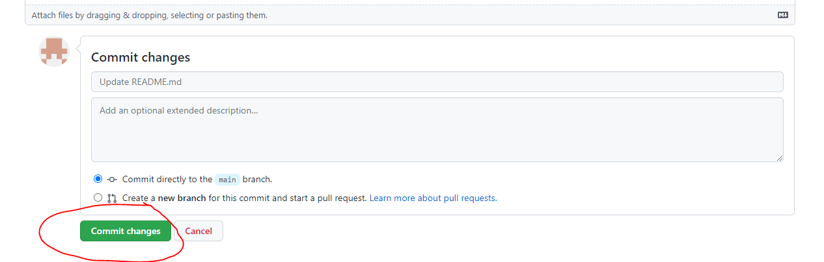

**Step 3: Add files to Github account**

1. Click on the repository created

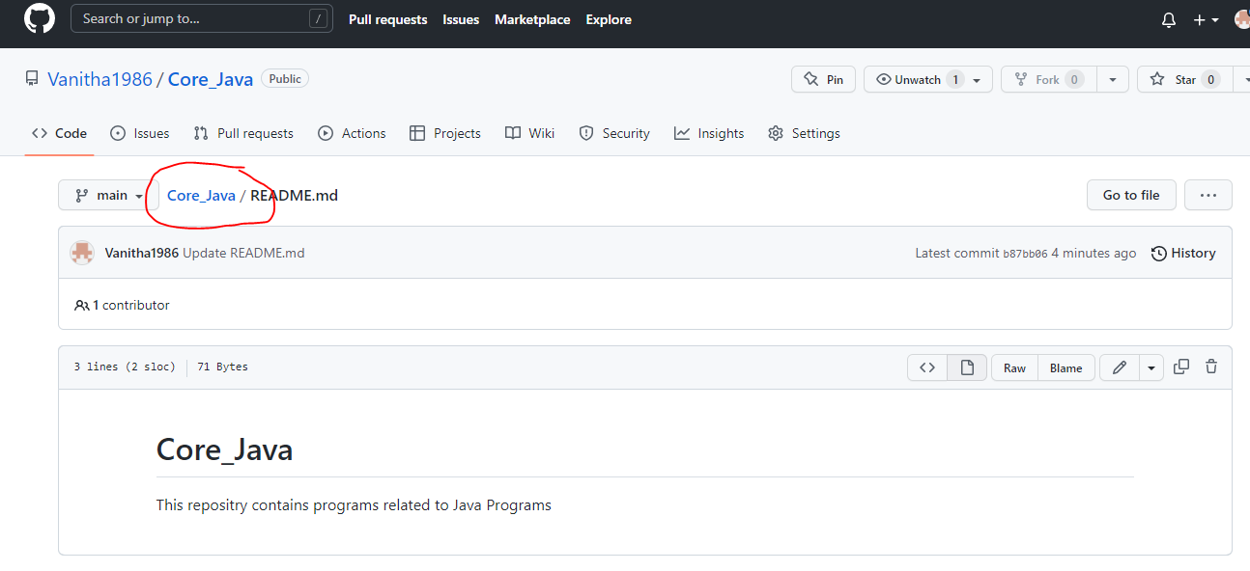

1. Click on add file🡪Upload file, browse for any of the files from local machine , upload and click on commit changes, then you should be able to see the file you have uploaded

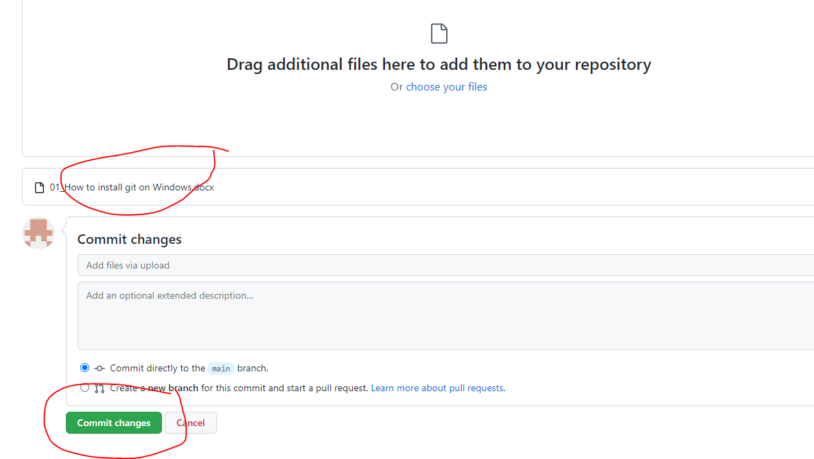

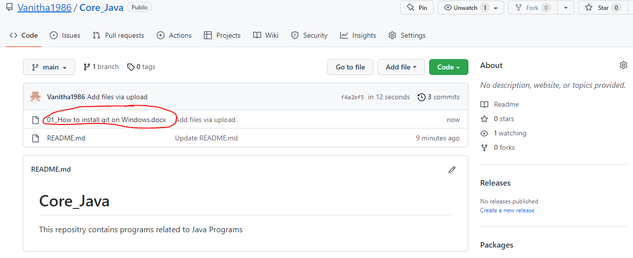

**Step 4: Installing git on windows**

1. To download the Git installer, visit the Git's official site and go to download page. The link for the download page is <https://git-scm.com/downloads>. The page looks like as

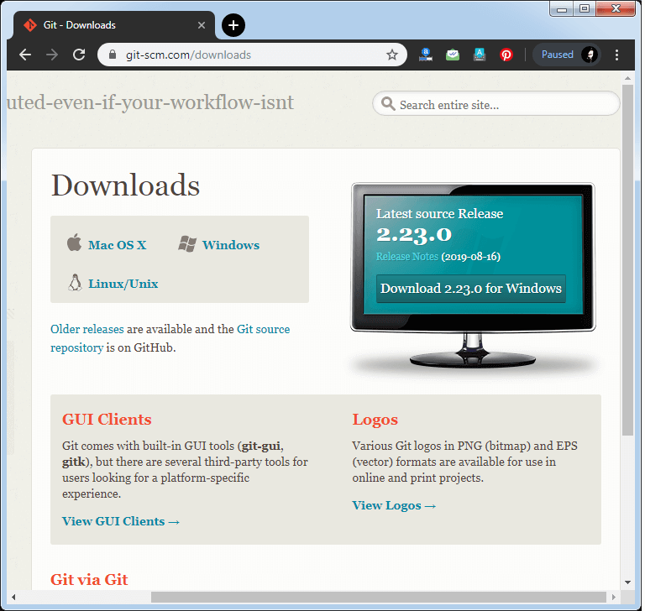

Click on the package given on the page as **download 2.23.0 for windows**. The download will start after selecting the package. Download the latest version, 32 bit/ 64 bit.

Now, the Git installer package has been downloaded.

## Click on the downloaded installer file and select ****yes**** to continue. After the selecting ****yes**** the installation begins, and the screen will look like as

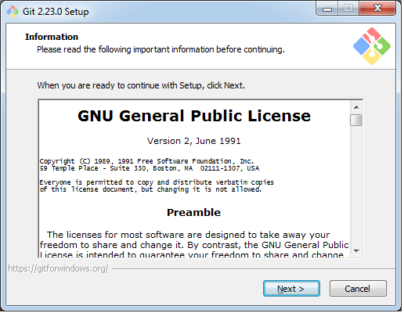

Click on **next** to continue.

1. Default components are automatically selected in this step. You can also choose your required part.

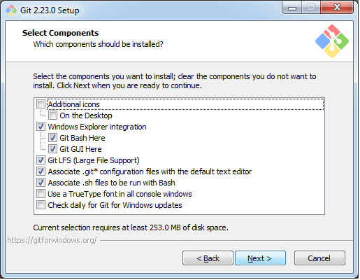

Click next to continue.

1. The default Git command-line options are selected automatically. You can choose your preferred choice. Click **next** to continue.

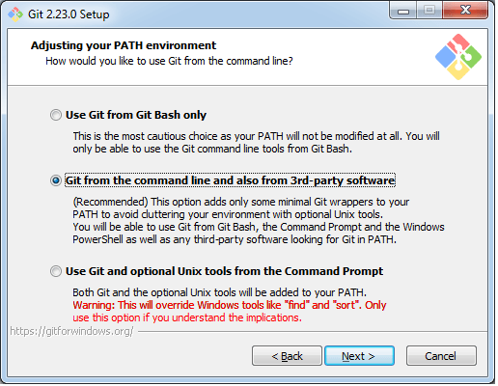

1. The default transport backend options are selected in this step. Click **next** to continue.

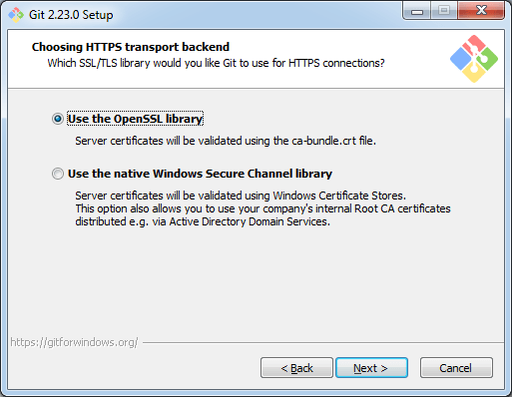

1. Select your required line ending option and click next to continue.

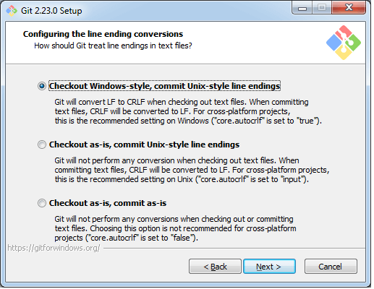

1. Select preferred terminal emulator clicks on the **next** to continue.

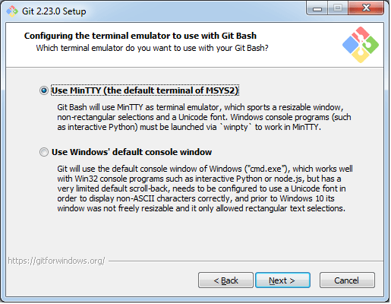

1. This is the last step that provides some extra features like system caching, credential management and symbolic link. Select the required features and click on the **next** option.

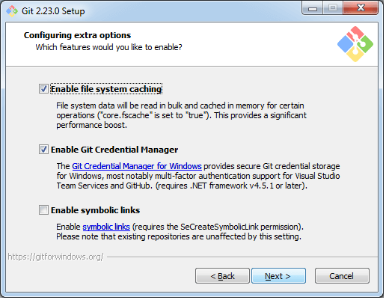

1. The files are being extracted in this step.

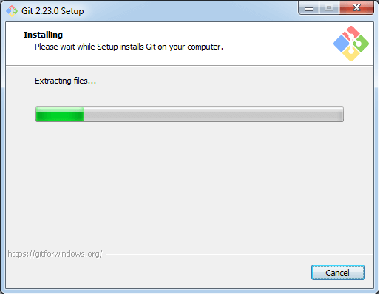

Therefore, The Git installation is completed. Now you can access the **Git Gui** and **Git Bash**.

The **Git Gui** looks like as

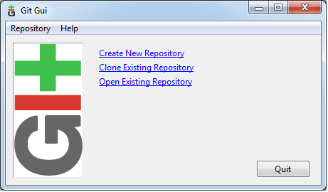

It facilitates with three features.

* Create New Repository
* Clone Existing Repository
* Open Existing Repository

The **Git Bash** looks like as

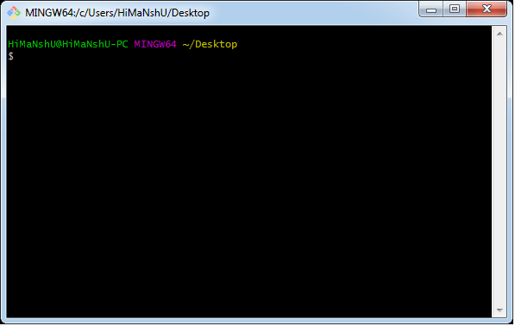

**Step 5: Launch the gitbash console, create a directory and clone the repository created in github**

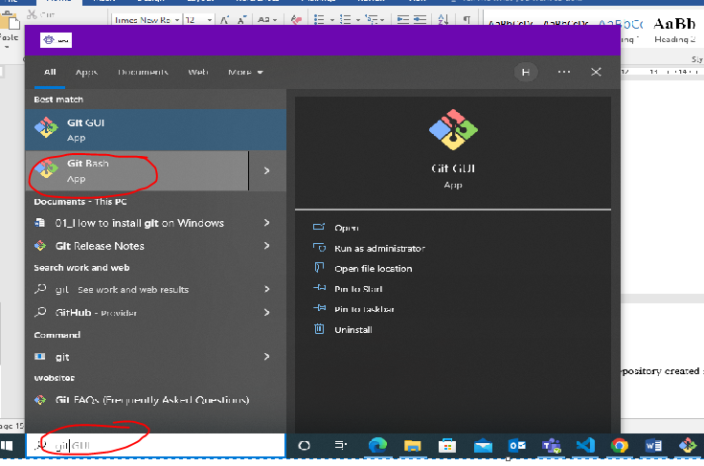

**Commands:**

Creating a directory: mkdir repo

Changing a directory: cd repo

Clone the repository created, go the github account you have created

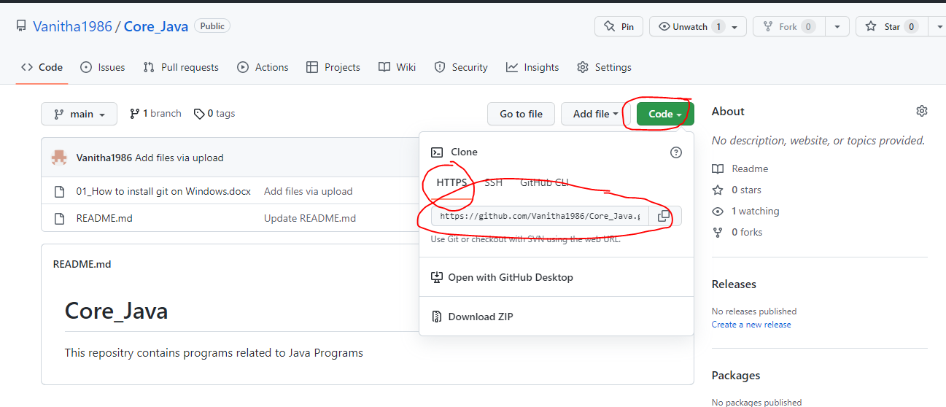

Copy the HTTPS link and use the command clone, as below

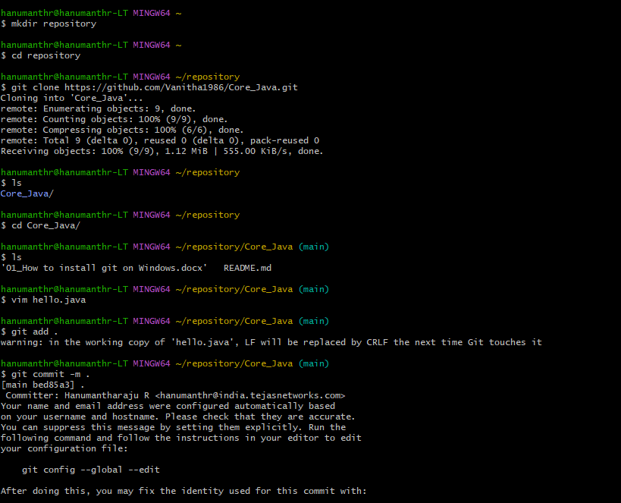

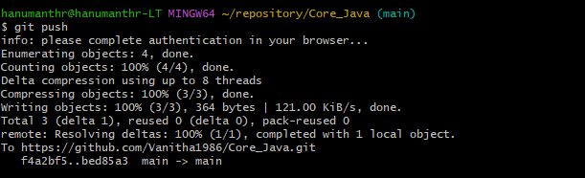

Refresh the github page, you should be able to see the hello,java file

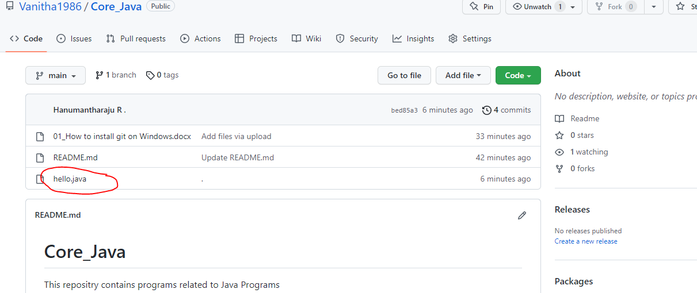

Now, create a file in github and run git pull command in local git

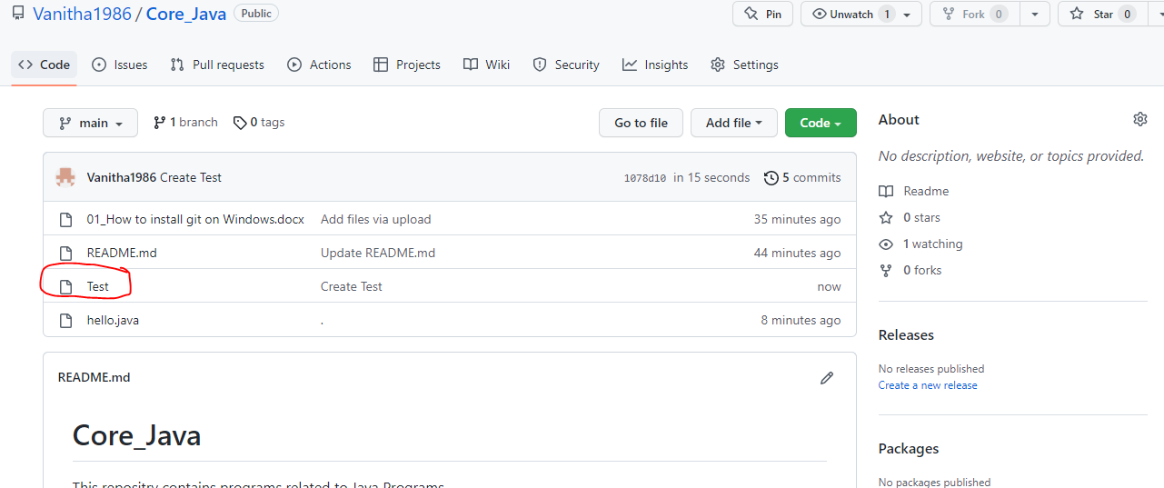

Run git pull command, run ls command to see the file which was created in github account

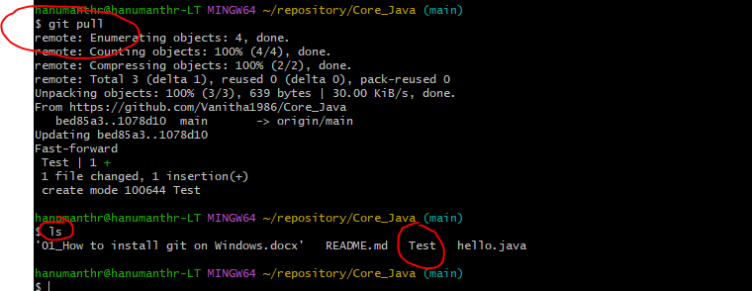

**Summary:**

* Learnt how to create github account
* Learnt how to install git in windows
* Explored the use some of the git commands like: clone, add, commit, push and pull